INST 327

Team 17

December 13, 2023

Himaja Mallampally, Abeezar Babuji, Claude Belizaire

**Electric Vehicles Final Project Report**

**Introduction:**

The electric vehicle revolution has taken over multiple parts of the world, as multiple companies are now creating hybrid and electric vehicles. In Washington state, electric vehicle usage has seen a boom, as customers are now seeking to replace regular vehicles with their electric counterparts. Our project delves into this phenomenon, analyzing a comprehensive database of registered Battery Electric Vehicles (BEVs) and Plug-in Hybrid Electric Vehicles (PHEVs). Nowadays, electric vehicles have taken over the future of cars, transportation, and the environment. We analyzed the dataset and now showcase how we can use the information included to appeal to potential stakeholders interested in EV data for business decisions.

Our exploration begins with the data itself. Upon cleaning, reducing, and organizing our EV dataset, the sample data section of this report contains a small list of vehicles sold in WA. Our analysis of this data gave inspiration to find a way to draw meaningful conclusions based on the columns present. By sharing our findings, we hope to contribute to a broader understanding of EV adoption in the greater Washington area. For industry stakeholders, this means our database will provide valuable insights for national marketing campaigns and product development. This will allow us to be able to see which vehicles are most popular, which ones qualify for the Clean Alternative Fuel Vehicle program, and which manufacturers have the biggest share in the EV market in Washington among many other things.

**Database Description**

**Logical Design:**

Below is an image of our ERD which became our physical database. This ERD contains eight different tables, including electric vehicles, location, county, EV utility, state, socioeconomic data, legislative district, and demographics.

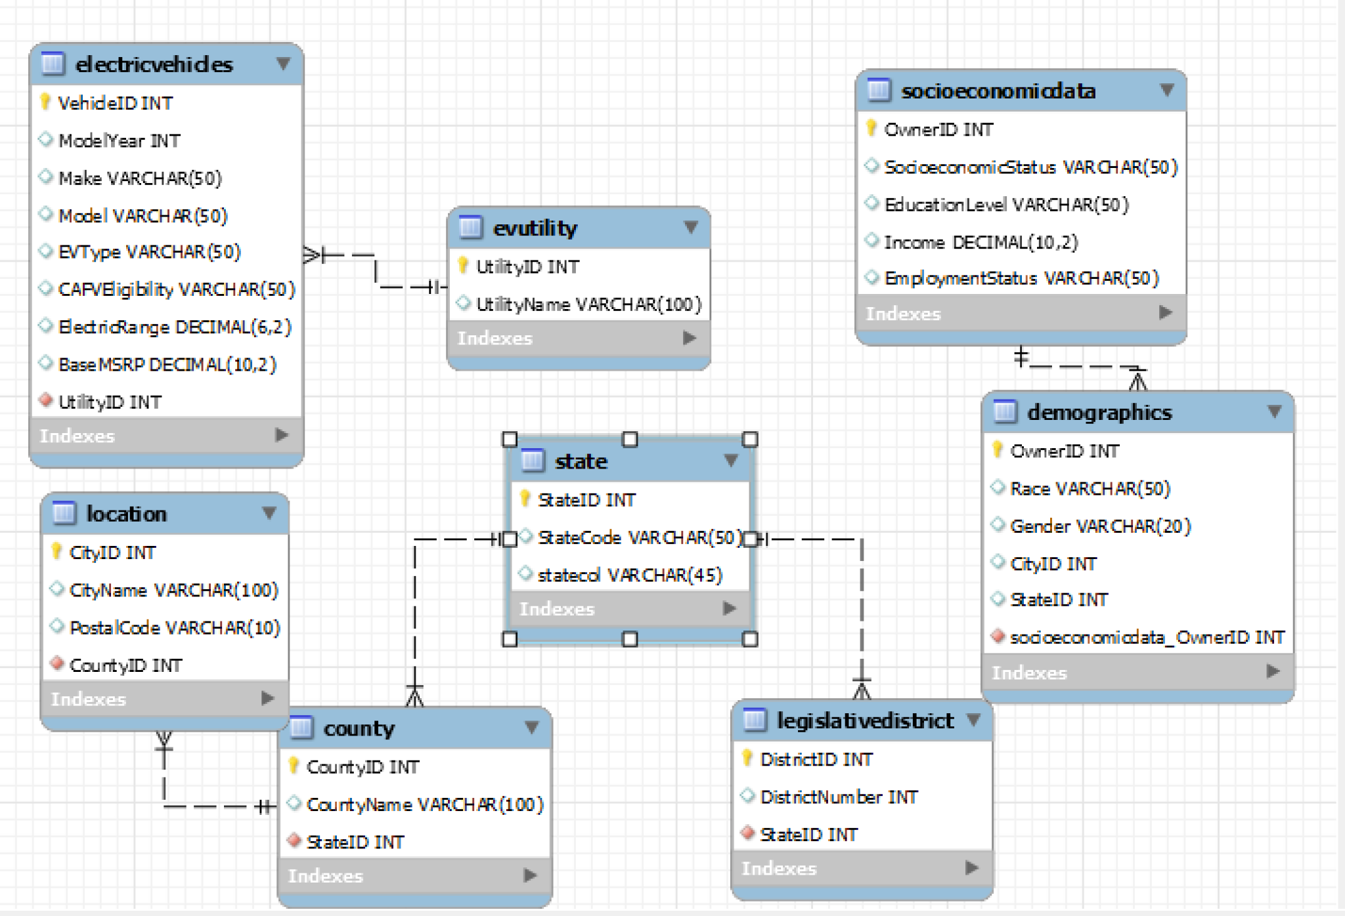

**Physical Database:**

Our database is focused on showing the information on the Electric Vehicles in the Washington State area. This includes the make, model, year, price, eligibility for Clean Alternative Fuel program eligibility, and price amongst other helpful information such as the type of EV the car is. To reach this point in our database, we ensured each table had most of its functionalities as standalone before putting together the schema that created this database. Some issues were encountered when running queries on certain tables which was cause for concern, but we quickly remedied this by updating the primary keys and foreign keys to ensure referential integrity making our database fully operational.

**Sample Data:**

Below is our sample data which we used to run our queries. It includes 60 rows, but we showcased the required 15 here to preview our miniature dataset. We used the given data sources to obtain the information we needed to pull the data regarding the usage of electric vehicles in Washington State, but also how they are used within different demographics across the state and areas around it.

**Views / Queries:**

| **View Name** | **Req. A** | **Req. B** | **Req. C** | **Req. D** | **Req. E** |
| --- | --- | --- | --- | --- | --- |
| **Query_CleanVehiclesEligible** |  |  |  |  |  |
| **Query _IPluginHybridsCount** |  |  |  |  |  |
| **Query_AvgElectricRangeByMake** |  |  |  |  |  |
| **Query_movie X**  **s_count** |  |  |  |  |  |
| **Query_find_a _movie** |  |  |  |  | |

**Changes From Original Design:**

Our plans have evolved slightly; we've refined our focus on demographic diversity and inclusion within the database, aligning with feedback and deeper research insights. Using our mentor’s help, We were able to take feedback on continuing our initial choices for the ERD based on the feedback received from our submission. The mentor briefly mentioned adding small details to our current design which would help refine the findings that we had. Additionally, we've expanded the database's attributes to include more parameters related to socioeconomic backgrounds and geographic locations to enhance inclusiveness.

**Database Ethics Considerations:**

Given the nature of our project and the lack of demographic information in the dataset, we find it impossible to misinterpret or misuse our database in an unethical manner. The information presented in our database only considers electric vehicles and their sales in the Washington area which does not reveal any personal or sensitive information about the buyers or sellers. Therefore, database ethics considerations of diversity, equity, inclusion, data privacy, fair use, and other ethical considerations did not impact our project significantly. However, we still followed the best practices of database design, such as ensuring data integrity, consistency, and security. We also acknowledged the sources of our data and respected their licenses and terms of use. Even if our database was to fall into the wrong hands they would not have any means to exploit it in a way that would cause ethical harm.

**Lessons Learned:**

Throughout the semester we learned many things. Most notably, setting up a proper logical design is key to ensuring a functional database. Although this is obvious at first sight, we slightly overlooked this fact early in the semester since our knowledge of relational database management was newfound. As discussed in our changes from the original design, we found that our ERD visually made sense. Still, practically speaking, it made for a terrible choice when it came to solving the problems stated in our proposal. This means moving forward, a concise logical design and ERD make for an efficient database with predictable behavior if implemented correctly.

**Potential Future Work:**

Our project achieved a major milestone by creating a database from the initial dataset that we received and improved. Since the dataset only covered EVs in Washington state, a possible next step could be to expand the scope to the whole country. The same queries would work, but with some skills in data analysis and visualization, we could present the data more clearly and engagingly for our audience.

**Conclusion:**

In this project, we have analyzed the electric vehicle (EV) population data in Washington, USA, using a relational database model. We have designed an Entity-Relationship Diagram (ERD) that captures the relevant attributes and relationships of the EV data, such as the location, type, model, price, and utility of the vehicles. We have also performed various queries on the database to answer some research questions, such as the distribution of EVs by county, city, and legislative district, the most popular EV models and makes, the average electric range and base MSRP of different EV types, and the correlation between CAFV eligibility and EV utility. Our analysis has revealed some interesting insights and trends about the EV market and adoption in Washington, which can be useful for policymakers, manufacturers, consumers, and researchers. We hope that our project can contribute to the understanding and promotion of clean and sustainable transportation in the state and beyond.